**COMSATS University Islamabad,   
 Abbottabad Campus**

**Project Proposal   
(SCOPE DOCUMENT)**

**for**

**VideoVigil**  
Version 1.0

***By***

**Nabeel Ahmad CIIT/FA20-BSE-170/ATD**

**Mubashir Ahmed CIIT/FA20-BSE-063/ATD**

**Ghulam Abbass CIIT/FA20-BSE-053/ATD**

***Supervisor*Ma`am Neeli Khan**

***Bachelor of Science in Computer Science (2020-2024)***

|  |  |  |
| --- | --- | --- |
| **No.** | **Comment** | **Action** |
|  |  |  |
|  |  |  |
|  |  |  |
|  |  |  |
|  |  |  |
|  |  |  |

**SCOPE DOCUMENT REVSION HISTORY**

**Supervisor Signature**

**Date:**

**Table of Contents**

1. **Introduction 5**
2. **Problem Statement 5**
3. **Problem Solution for Proposed System 6**
4. **Related System Analysis/Literature Review 6**
5. **Advantages/Benefits of Proposed System 7**
6. **Scope 7**
7. **Modules 8**

7.1Module 1: Data Creation 8

7.2 Module 2: Data Training 8

7.3 Module 3: Data Testing 8

7.4 Module 4: Development of Web Extension 8

7.5 Module 5: Deployment and Integration 8

1. **System Limitations/Constraints 8**
2. **Software Process Methodology 9**
3. **Tools and Technologies 9**
4. **Project Stakeholders and Roles 10**
5. **Team Members Individual Tasks/Work Division 10**
6. **Data Gathering Approach 10**
7. **Concepts 11**
8. **Gantt chart 11**
9. **Mockups 12**
10. **Conclusion 13**
11. **References 13**
12. **Plagiarism Report 15**

**Project Category: (**Select all the major domains of proposed project**)**

** C-** Problem Solving and Artificial Intelligence

**Abstract**

The project, VideoVigil, addresses the critical issue of online content that portrays violence or sensitive material, which can have detrimental effects on viewers' mental well-being. In response, our project aims to develop a robust deep learning model capable of detecting instances of violence within videos. Upon detection, the model will automatically generate warnings, alerting users to the potentially distressing content and allowing them to make informed choices about their viewing experience. The goal is to deploy this innovative solution as a web browser extension, providing a user-friendly and accessible tool for enhancing online safety and content moderation. By achieving this, VideoVigil contributes to a safer and more considerate online environment, prioritizing the well-being of internet users.

# **Introduction**

The purpose of this project proposal is to develop a deep learning model that can detect violence in videos and automatically generate a warning, informing users to watch it at their own risk. The model will be deployed as a web browser extension, so it can be used to scan and mark videos on internet platforms. The project is motivated by the observation that videos displaying violence or sensitive content can be harmful and negatively impact a person's mental health. For example, exposure to graphic violence can lead to post-traumatic stress disorder (PTSD), anxiety, and depression. Children and adolescents are particularly vulnerable to the negative effects of exposure to violence in the media. The proposed deep learning model will be able to detect violence in videos by extracting features from the video, such as audio. The model will then use these features to classify the video as either violent or non-violent. The model will be trained on a dataset of labeled videos, containing both violent and non-violent content. The dataset will be collected from a variety of sources, such as social media platforms and news websites. Once the model is trained, it will be deployed as a web browser extension. The extension will scan videos on various platforms and mark any videos that are classified as violent with a warning. The warning will inform users to watch the video at their own risk. The proposed project has the potential to make a significant contribution to the field of online safety by helping users avoid exposure to potentially harmful content. The project can also be used to raise awareness of the dangers of online violence and promote responsible use of internet.

Background

The problem of online violence is a growing concern. A recent study found that 60% of adolescents have been exposed to violence online. Exposure to online violence can lead to several negative consequences, including anxiety, and depression. Deep learning models have been shown to be effective at detecting violence in videos. In a recent study, a deep learning model was able to detect violence in videos with an accuracy of 95%.However, there are still some challenges that need to be addressed before deep learning models can be widely used to detect violence in videos. One challenge is that deep learning models can be computationally expensive to train and deploy. Another challenge is that deep learning models can be biased, reflecting the biases present in the data they are trained on. The proposed project will address these challenges by developing a deep learning model that is efficient to train and deploy, and by using a dataset that is carefully curated to minimize bias.

# **Problem Statement**

The browser extension we are developing addresses the critical issue of online violence and sensitive content within videos, which can have severe repercussions on users' mental well-being. Our system's primary objective is to autonomously detect such content and issue warnings to users, empowering them to make informed decisions regarding their video consumption. The motivation behind this project stems from the growing need for enhanced online safety, particularly on internet platforms, where users encounter a multitude of videos daily.

While various content moderation tools exist, a comprehensive solution for automatically identifying and flagging potentially distressing videos is not widely accessible. Many existing systems rely on manual reporting or basic keyword-based algorithms, which leaves room for harmful content to evade detection. Our browser extension stands out by harnessing the power of deep learning to autonomously identify violent content, thereby improving online safety for users. The project's uniqueness lies in its potential deployment as a browser extension, ensuring easy accessibility for a wide user base. The re-implementation of such a system offers an invaluable opportunity for learning. It provides practical experience in developing, training, and deploying deep learning models for real-world applications. Additionally, it fosters proficiency in browser extension development, a highly relevant and sought-after skill in today's digital landscape.

Through this project, we anticipate gaining proficiency in various areas. This includes expertise in deep learning model development, encompassing data preprocessing, model architecture design, and optimization. We also expect to acquire skills in dataset curation and bias mitigation, recognizing the paramount importance of a balanced and unbiased dataset.

# **Problem Solution for Proposed System**

The primary problem we aim to solve with our system is the pervasive presence of violence and sensitive content within online videos, which poses a significant risk to individuals' mental well-being. Exposure to graphic violence, hate speech, and distressing materials can lead to adverse psychological effects, including post-traumatic stress disorder (PTSD), anxiety, and depression. This issue is particularly concerning for young individuals and adolescents who may be more susceptible to the harmful effects of violent media.

While there are existing content moderation tools, they often rely on manual reporting or basic keyword-based algorithms, leaving gaps in detecting harmful content. Our system utilizes advanced deep learning technology to identify violent content comprehensively and autonomously within videos. Unlike traditional methods, our approach considers a wide range of video features, such as audio, enabling more accurate content classification.

The unique aspect of our solution lies in its deployment as a browser extension. This extension seamlessly integrates into popular web browsers, ensuring accessibility to a broad user base across various internet platforms. As users interact with videos online, our extension actively scans video content in real-time. When it detects potentially distressing material, it immediately issues a warning to users, encouraging them to exercise caution or make an informed choice about viewing the video.

By addressing the problem of automated content moderation through deep learning, our system enhances online safety for users. It provides a proactive defense against harmful content and empowers users to take control of their online experiences by avoiding potentially distressing material. Additionally, our system is designed for continuous learning and improvement, adapting to evolving online content trends and ensuring long-term effectiveness.

# **Related System Analysis/Literature Review**

Following are the related top marked system analysis that have been performed:

**Related System Analysis with proposed project solution**

|  |  |  |
| --- | --- | --- |
| **Application Name** | **Weakness** | **Proposed Project Solution** |
| ChildSafe | - ChildSafe Video has been criticized for not being very effective at filtering out violence. | Our project aims to enhance ChildSafe Video by implementing advanced deep learning models that analyze video content, motion, and audio to identify violence more effectively. |
| StreamGuard | - StreamGuard primarily relies on metadata and user reporting, which can result in delayed responses to violent content. | StreamGuard Our project seeks to improve StreamGuard by incorporating real-time video analysis and machine learning algorithms to detect and flag violence promptly. |
| WebSearch Shield | - WebSearch Shield uses traditional rule-based filters that may produce false positives and false negatives in violence detection. | The proposed project provides a more sophisticated approach, utilizing deep neural networks and natural language processing to refine violence content filtering and reduce false alarms. |

# **Advantages/Benefits of Proposed System**

* **Increased accuracy**: Our web extension is designed to be more accurate than existing violence detection systems. This is because it will use a deep learning model that is specifically trained to detect violence in videos.
* **Reduced bias**: Our web extension is designed to be less biased than existing violence detection systems. This is because it will be trained on a large and diverse dataset of videos.
* **Scalability:** Our web extension is designed to be scalable, so that it can be deployed on a large scale. This is important because it will allow the extension to be used by many people.
* **Efficiency:** Our web extension is designed to be efficient, so that it does not slow down the user's browsing experience. This is important because it will make the extension more user-friendly.
* **Ease of use:** Our web extension is designed to be easy to use. Users will simply need to install the extension and it will automatically start scanning videos for violence.

# **Scope**

The scope of this web extension project is centered on the development of a specialized web browser extension designed to filter and detect violent content within online videos. It will serve as a vigilant protector, actively scanning videos on various websites, and utilizing a deep learning model to accurately identify violent content. The core functionalities of the proposed project include real-time video analysis, violence detection, and the generation of warning messages to alert users about potentially distressing content.

A crucial aspect of the project's scope involves the acquisition, curation, and management of a comprehensive dataset comprising a diverse range of labeled videos. This dataset will serve as the foundation for training the deep learning model, ensuring that it attains high accuracy in violence detection. The project aims to develop an efficient, effective, and responsible solution to mitigate users' exposure to harmful content, thereby promoting online safety and safeguarding mental well-being.

It's important to note that the project's scope is focused on the core functionalities of violence detection and warning generation, with the primary goal of creating a web extension that seamlessly integrates with users' online experiences. The scope does not encompass the development of a full video streaming platform or extensive user interface design. Instead, it prioritizes the essential elements required to achieve the project's objectives—filtering and alerting users to violent content—within the framework of a web extension. This approach ensures a user-friendly and unobtrusive solution that contributes to a safer online environment.

# **Modules**

# Module 1: Data Creation

The Data Training module is pivotal for training the deep learning model. It involves preprocessing, feature extraction, and model training using the curated dataset.

Special Feature: Transfer Learning - To enhance efficiency and accuracy, this module leverages transfer learning techniques, using pre-trained models as a starting point for violence detection.

# Module 2: Data Training

The Data Training module is pivotal for training the deep learning model. It involves preprocessing, feature extraction, and model training using the curated dataset.

Special Feature: Transfer Learning - To enhance efficiency and accuracy, this module leverages transfer learning techniques, using pre-trained models as a starting point for violence detection.

# Module 3: Data Testing

The Data Testing module assesses the model's performance by evaluating its ability to accurately detect violence in videos. It involves testing the model on a separate test dataset.

Special Feature: Real-time Analysis - This module includes a real-time analysis component that allows the extension to scan and classify videos as they appear on inter platforms in real-time.

# Module 4: Development of Web Extension

The Development of Web Extension module focuses on building web browser extension that integrates seamlessly with popular browsers. It provides the user interface for interacting with the extension.

Special Feature: User-Friendly Interface - This module ensures an intuitive and user-friendly interface, with a simple warning message overlay on videos flagged as violent.

# Module 5: Deployment and Integration

The Deployment and Integration module involves deploying the web extension to browsers and ensuring its compatibility with different browsers and platforms.

Special Feature: Cross-Browser Compatibility - This module ensures that the extension works smoothly across a variety of web browsers, making it accessible to a wider user base.

# **System Limitations/Constraints**

Here are some limitations and constraints of the proposed VideoVigil project to develop a system that can detect violence in videos:

* The accuracy of the system will depend on the quality of the training dataset. If the dataset is not large enough or if it is not representative of the real world, the system may not be able to accurately detect violence in videos.
* The system may be biased, reflecting the biases present in the training dataset. This means that the system may be more likely to misclassify videos from certain groups of people.
* The system may be computationally expensive to train and deploy. This means that it may not be feasible to deploy the system on all devices.
* The system may be susceptible to adversarial attacks. Adversarial attacks are carefully crafted inputs that are designed to fool machine learning models.
* The system may not be able to detect violence in real time. This is because video processing can be computationally expensive.

# **Software Process Methodology**

I have chosen the Agile software methodology for my project to develop a VideoVigil system that can detect violence in videos. Agile is a software development methodology that emphasizes iterative development, teamwork, and adaptability. It is well-suited for complex projects, such as my own, because it allows for changes to be made quickly and easily.

Here are some of the reasons why I have chosen the Agile methodology:

* It is iterative. Agile projects are divided into short sprints, typically two weeks long. At the end of each sprint, the team delivers a working product that is evaluated by stakeholders. This feedback is then used to improve the product in the next sprint.
* It is collaborative. Agile teams are cross-functional and work together closely throughout the development process. This collaboration helps to ensure that everyone is on the same page and that the product meets the needs of all stakeholders.
* It is adaptable. Agile projects are designed to be adaptable to change. This is important because the requirements for software projects often change over time. Agile teams can quickly and easily adapt to these changes without sacrificing quality.

# **Tools and Technologies**

Following are the tools and technologies for VideoVigil.

**Tools and Technologies for Proposed Project**

|  |  |  |  |
| --- | --- | --- | --- |
| **Tools**  **And**  **Technologies** | **Tools** | **Version** | **Rationale** |
| MS Visual Studio | 2015 | IDE |
| MS SQL Server/Mangodb | 2015 | DBMS |
| Pycharm | 2020.2 | IDE |
| Jupyter Notebook | 6.0.3 | IDE |
| Figma | CSC 6 | Design Work |
| MS Word | 2015 | Documentation |
| MS Power Point | 2015 | Presentation |
| Canva | 2.0.5 | Mockups Creation |
| **Technology** | **Version** | **Rationale** |
| Python | 6.0 | Programming language |
| Firebase | 2013 | Database |
| TensorFlow | 2.0 | Framework |

# **Project Stakeholders and Roles**

**Project Stakeholders for Proposed Project**

|  |  |
| --- | --- |
| **Project Sponsor** | COMSATS University, Islamabad , Abbottabad Campus |
| **Stakeholder** | * Students : * Nabeel Ahmad * Mubashir Ahmed * Ghulam Abbas * Project Supervisor Name: Miss Neeli Khan * Final Year Project Committee: * M. Tariq Baloch * M. Ibtisam Gul * Sundas Shujah * Sumair Khan |

# 

# **Team Members Individual Tasks/Work Division**

**Team Member Work Division for Proposed Project**

|  |  |  |
| --- | --- | --- |
| **Student Name** | **Student Registration Number** | **Responsibility/ Modules** |
| Nabeel Ahmad | FA20-BSE-170 | Module: 1,5 |
| Mubashir Ahmed | FA20-BSE-063 | Module: 2,3 |
| Ghulam Abbas | FA20-BSE-053 | Module: 4 |

# **Data Gathering Approach**

Following are the design gathering approaches that will be effective in case of VideoVigil.

* **Interviews:**

We will conduct interviews with potential users, including individuals who consume online video content regularly and those who have experienced distressing content. These interviews will help us understand user perspectives, pain points, and expectations regarding content filtering and warnings.\

* **Surveys:**

Surveys will be distributed to a broader audience to collect quantitative data on users' experiences and preferences related to online video content. This approach will provide us with statistical insights into user behavior and preferences.

* **Research:**

Extensive research will be conducted to review existing literature on the impact of violent content on mental health, as well as studies related to content filtering and detection algorithms. This research will inform our project's design and approach.

* **Group Meetings:**

Regular group meetings will be conducted among project team members. These meetings will serve as forums for brainstorming, sharing ideas, and discussing the progress of the project. Group meetings will enable us to align our understanding of project goals and objectives.

* **Supervisor:**

Discussions: We will engage in frequent discussions with our project supervisor. These discussions will provide an opportunity to seek guidance, share project updates, and receive feedback. Our supervisor's expertise and insights will be invaluable in shaping the project's direction and ensuring that it aligns with academic and industry standards.

# **Concepts**

**Concept-1: Deep Learning**

Our project heavily involves the use of deep learning techniques for violence detection in videos. We will learn about various deep learning architectures, including convolutional neural networks (CNNs) and recurrent neural networks (RNNs). Understanding how to train and fine-tune these models for video analysis will be a significant learning outcome.

**Concept-2: Data Preprocessing**

Effective data preprocessing is essential for model performance. We will delve into techniques such as data augmentation, feature extraction, and data normalization to prepare our video dataset for training. This concept is crucial for enhancing the quality of input data.

**Concept-3: Web Browser Extension Development**

Developing a web browser extension requires knowledge of web technologies, including HTML, CSS, and JavaScript. We will learn how to create browser extensions that can interact with web content and provide users with warnings based on our deep learning model's predictions.

**Concept-4: Ethical Considerations in AI**

As our project involves content filtering and warnings, we will explore the ethical considerations of AI and machine learning. This includes issues related to bias, fairness, and privacy in AI models, which are crucial for responsible development and deployment.

# **Gantt chart**

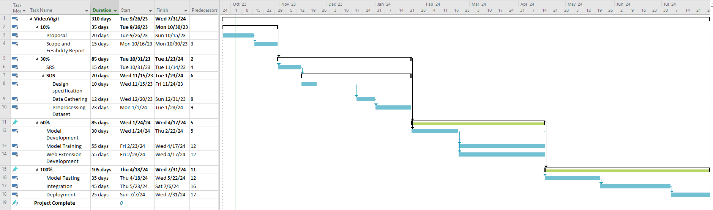

# **Mockups**

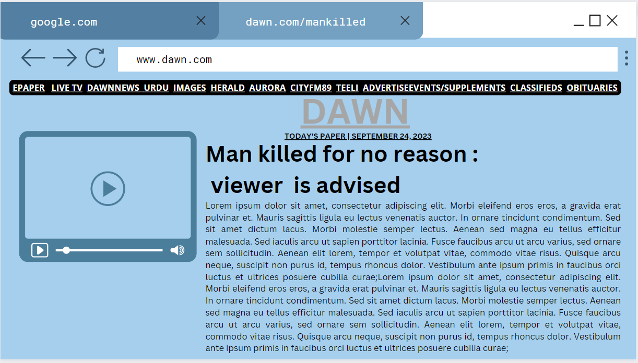

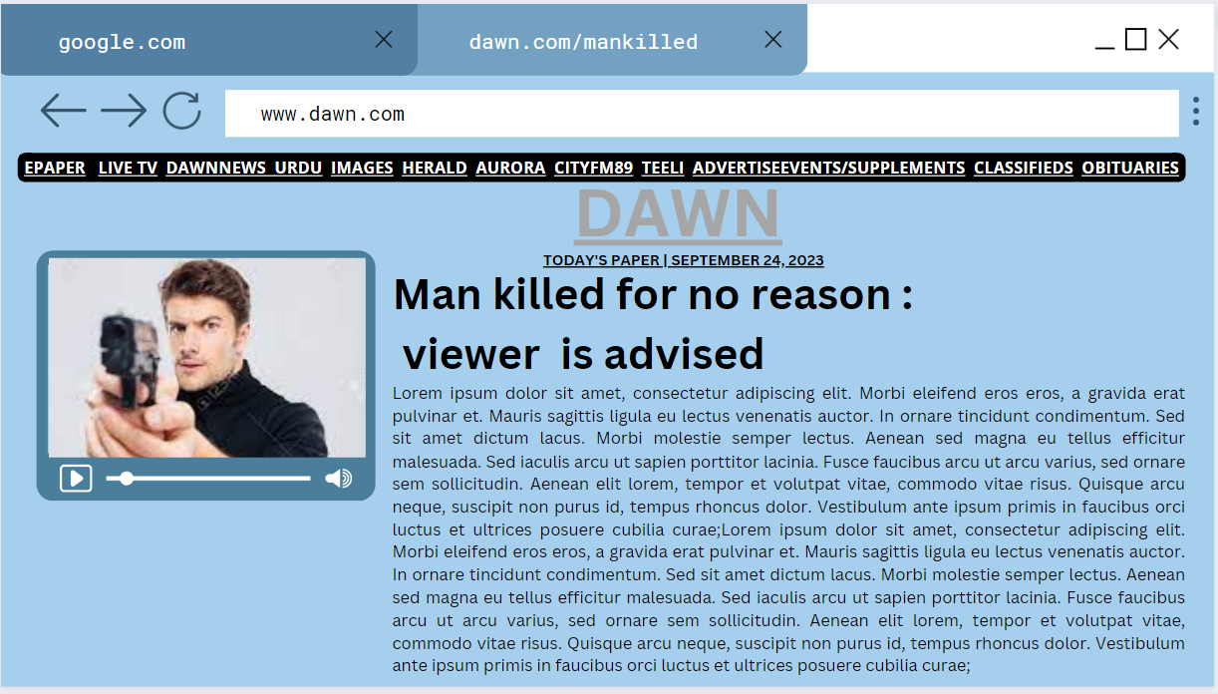



# **Conclusion**

In conclusion, the VideoVigil project aims to develop a web browser extension that harnesses the power of deep learning to detect violence in online videos and provide users with warnings. This project is motivated by the pressing need to protect individuals from exposure to harmful content that can have adverse effects on mental health. By filtering and flagging violent videos on intenet platforms, we aspire to create a safer online environment. As we embark on this project, we look forward to the challenges and opportunities it will bring, and we are committed to its successful execution and the positive impact it can have on individuals' well-being in the digital age.

# **References**

**Books:**

* "Deep Learning for Computer Vision" by Adrian Rosebrock
* "Computer Vision: A Modern Approach" by David G. Lowe
* "Machine Learning: A Probabilistic Perspective" by Kevin P. Murphy

**Research papers:**

* "A Two-Stream Convolutional Neural Network for Action Classification" by Karen Simonyan and Andrew Zisserman
* "Fast R-CNN" by Ross Girshick
* "Faster R-CNN: Towards Real-Time Object Detection with Region Proposal Networks" by Shaoqing Ren, Kaiming He, Ross Girshick, and Jian Sun

**References:**

1. [**https://arxiv.org/abs/2209.11680**](https://arxiv.org/abs/2209.11680)
2. [**https://iopscience.iop.org/article/10.1088/1742-6596/2318/1/012003**](https://iopscience.iop.org/article/10.1088/1742-6596/2318/1/012003)
3. [**https://www.cs.cmu.edu/~rahuls/pub/caip2011-rahuls.pdf**](https://www.cs.cmu.edu/~rahuls/pub/caip2011-rahuls.pdf)
4. [**https://www.mdpi.com/1424-8220/22/6/2216**](https://www.mdpi.com/1424-8220/22/6/2216)
5. [**https://www.ncbi.nlm.nih.gov/pmc/articles/PMC9044356/**](https://www.ncbi.nlm.nih.gov/pmc/articles/PMC9044356/)
6. [**https://link.springer.com/chapter/10.1007/978-3-642-23678-5_39**](https://link.springer.com/chapter/10.1007/978-3-642-23678-5_39)
7. [**https://ieeexplore.ieee.org/document/9892660/**](https://ieeexplore.ieee.org/document/9892660/)
8. [**https://pianalytix.com/violence-detection-using-ml/**](https://pianalytix.com/violence-detection-using-ml/)
9. [**https://www.sciencedirect.com/science/article/pii/S1077314223001194**](https://www.sciencedirect.com/science/article/pii/S1077314223001194)
10. [**https://www.abtosoftware.com/blog/violence-detection**](https://www.abtosoftware.com/blog/violence-detection)
11. [**https://journals.plos.org/plosone/article?id=10.1371/journal.pone.0203668**](https://journals.plos.org/plosone/article?id=10.1371/journal.pone.0203668)
12. [**https://www.techscience.com/cmc/v69n2/43878/html**](https://www.techscience.com/cmc/v69n2/43878/html)
13. [**https://www.tandfonline.com/doi/full/10.1080/08839514.2020.1723876**](https://www.tandfonline.com/doi/full/10.1080/08839514.2020.1723876)
14. [**https://www.worldscientific.com/doi/10.1142/S2196888820500013**](https://www.worldscientific.com/doi/10.1142/S2196888820500013)
15. [**https://dl.acm.org/doi/10.1145/3561971**](https://dl.acm.org/doi/10.1145/3561971)

# **Plagiarism Report**

